Do Socioeconomic Factors and the Number of Teachers in a School Affect Students’ Performance Based on ACT/SAT Scores?
While student performance often varies across schools and communities, many factors contribute to these academic differences. The goal of this project is to utilize real-world data to determine whether socioeconomic factors and the number of teachers in a school significantly influence student performance. Specifically, we will examine how ACT scores vary across high schools based on variables such as number of teachers in a school, unemployment rate, percentage of adults with college degrees, percentage of children in married couple families, median household income, average ACT scores, and percentage of students receiving free or reduced lunch. The datasets used in this analysis are obtained from the National Center for Education Statistics (NCES) and include school-level information on academic performance and demographic indicators. The data were cleaned and merged as needed to ensure consistency across schools. Understanding how these factors relate to standardized test outcomes can provide insight into the development of a predictive model to help predict how students will perform based on their background and the school’s background. We hypothesize that socioeconomic factors and teacher availability significantly influence students’ ACT or SAT performance.
During the data cleaning process, certain variables such as the percentage of students receiving free or reduced price lunch and average ACT scores from some schools contained implausible negative values. These rows were excluded from the analysis to maintain data integrity particularly regarding test scores. Furthermore, for numerical columns with missing entries, an iterative imputation approach was implemented to estimate and fill in the missing values
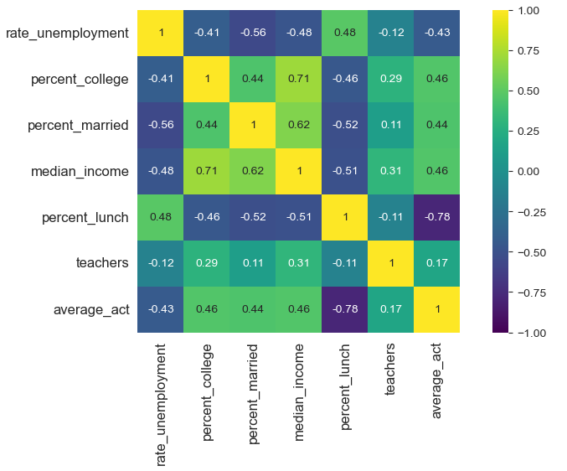
In order to understand the relationship between the variables, a correlation matrix of the numerical variables in the dataset was utilized. This is to provide an insight into the pairwise linear relationship between all the variables in our analysis. Below is the correlation matrix between the variables of interest in the analysis.
Since our interest is in the average ACT performance, let’s investigate the strength and direction of the linear relationships with each variable. The percentage of college, percentage married, and median income show a moderate positive correlation. There seems to be a weak positive correlation between the average ACT scores and the number of teachers. The rate of unemployment variable shows a moderate negative correlation while the percentage of free or reduced lunch offers a strong negative correlation. This suggests that, among all the factors we are considering, the number of teachers a school has may have the weakest relationship with performance. Additionally, we can see that some predictors are correlated with each other, which suggests that not all predictors will be necessary in the modeling.
Due to the linear relationship observed between the students’ performance and the numerical variables, a linear regression model can be utilized. While using a linear regression model, two key metrics used to assess model performance are R-squared and p-values. R squared measures the proportion of variance from a dependent variable and an independent variable, ranging from 0 to 1. A value of 1 would indicate that the model explains all the variability, while a value of 0 would indicate the opposite. For the p-values, just like R-squared, range from 0 to 1 measuring the probability of obtaining a result as extreme as one observed. A lower p-value would indicate that the observed data would be very unlikely to occur if the null hypothesis were true. Below is a visualization of the regression result.
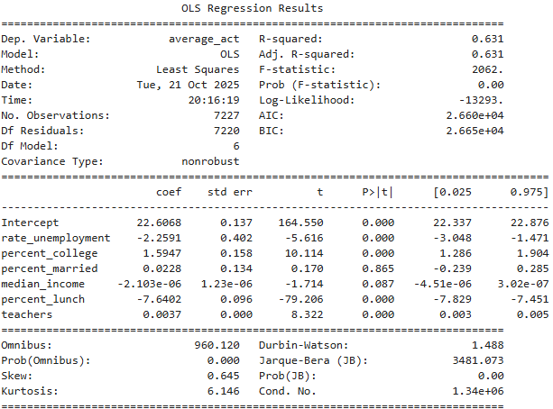
Initial comparison begins with the average ACT versus median income, resulting in a 0.211 R-squared and a p-value of 0.085. The linear regression model using number of teachers as a predictor resulted in a 0.30 R-squared and 0.0 p-value, and percentage married is 0.193 R-squared and a p-value 0.865. This analysis seems to align with the correlation matrix as seen above. In order to create a model that properly aligns with our topic, we fit all the variables to a multiple linear regression. According to the model summary, the R-squared value is 0.631. In other words, the model predictions are close to the actual data. Another way to look at the data is via a Mean Absolute Error (MAE). In the multiple linear regression model utilized in this project with all variables, the MAE quantifies the model prediction error by taking the absolute difference between the observed and predicted values. In this case, the MAE is 1.136. This indicates that the model can predict a student’s ACT outcome with an average error of 1.136, which is pretty close to the value. In summary, the multiple linear regression model that incorporates all socioeconomic predictors is able to predict ACT scores with an average error of about one point, indicating a strong overall fit. An examination of the residual plot suggests that applying transformations to the existing predictors would likely yield only limited improvement in model performance. However, not all predictors included in the model have statistically significant coefficients, meaning that some variables may have a weaker or negligible influence on ACT scores. While the current model performs well, introducing additional relevant predictors could potentially enhance its accuracy and explanatory power.
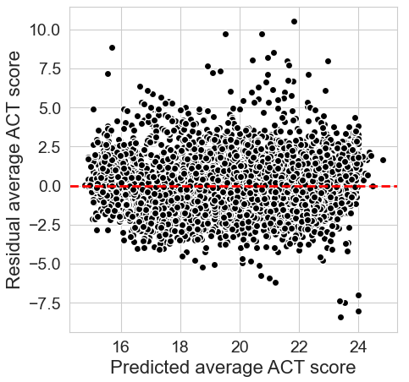
Similar to the model with all socioeconomic factors, we will use a model with only variables that have statistically significant values i.e., p-values less than 0.05). A residual plot can help understand the model’s accuracy. Below is the plot of the new model:
The x-axis represents predicted ACT scores from the model, while the y-axis represents the residuals, which is the difference between the actual ACT scores and the predicted scores. The residuals are fairly distributed around the zero line, with no clear pattern of curvature. Due to the lack of a clear pattern, this solidifies the assumption of linearity between the variables examined and the ACT scores. The spread of the variables shows that the model might have some errors, especially for performances at the lower or upper end of the range. With this model, the MAE was calculated and came to a value of approximately 1.137. This value quantifies the model’s average prediction error of 1, which is pretty similar to the model with all variables. This value is a small value and acceptable, suggesting that the models provide reasonable predictions of ACT performances at the school level based on the included socioeconomic and teacher related factors.
In conclusion, this project examines whether socioeconomic factors and the number of teachers in a school influence students’ performance, which is measured by the average ACT score or equivalent of the SAT. An analysis of the variables such as the number of teachers in a school and the other socioeconomic factors reveals that the percentage of students receiving free or reduced lunch showed the strongest correlation, while the teacher availability showcased a weaker but still positive relationship. A linear regression model comparing the average ACT score and either of the observations offers moderate explanatory power, while the multiple linear regression model combining all variables resulted in an R-squared of 0.631. This shows that approximately 63% of the variation in the score could be predicted with the model. Additionally, a MAE of 1.136 obtained from the model suggests that predictions are accurate within a one-point difference. Overall, the study shows that socioeconomic conditions have a substantially stronger impact on students’ performance than the number of teachers.

